Assigement No 3
Creted docker with Jenkins file in Build in Node
- Github repo- where 3 branch created and inside that index.html are present with Jenkins file, where all scripting I have wrote.
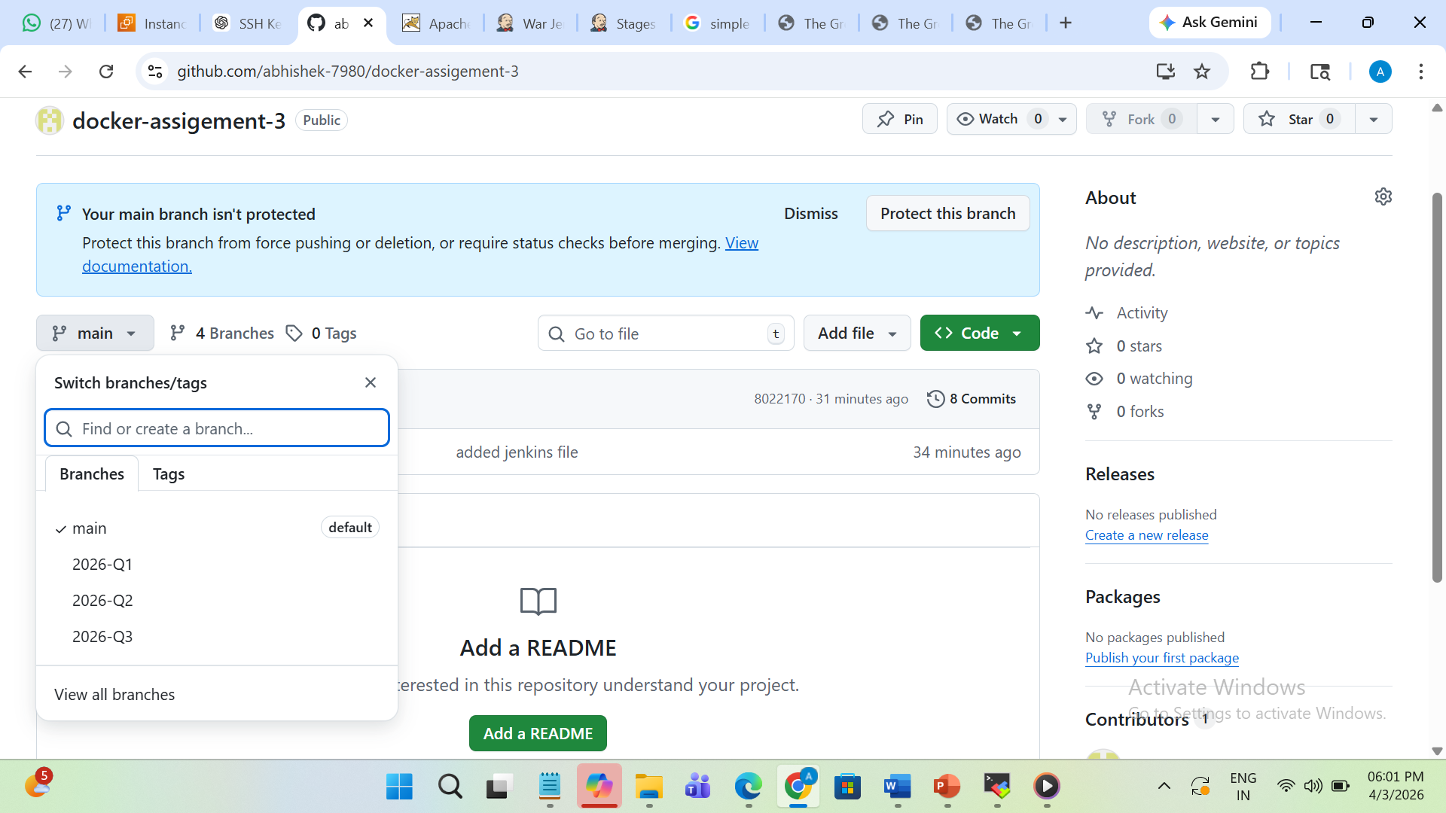

- This is my Jenkinsfile Script
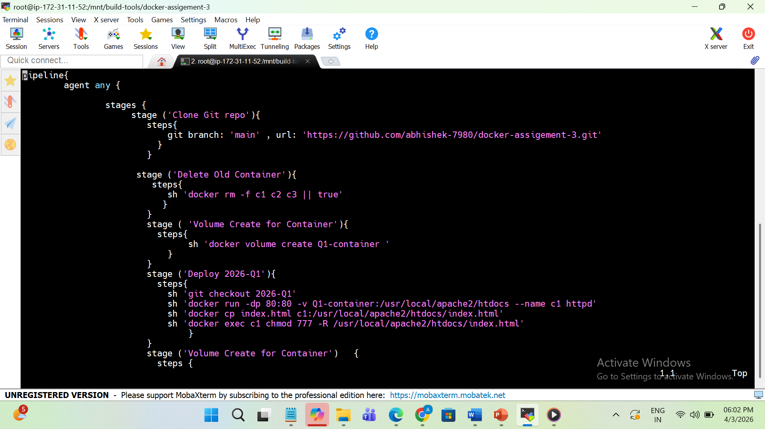
- Here I have successfully buid my project
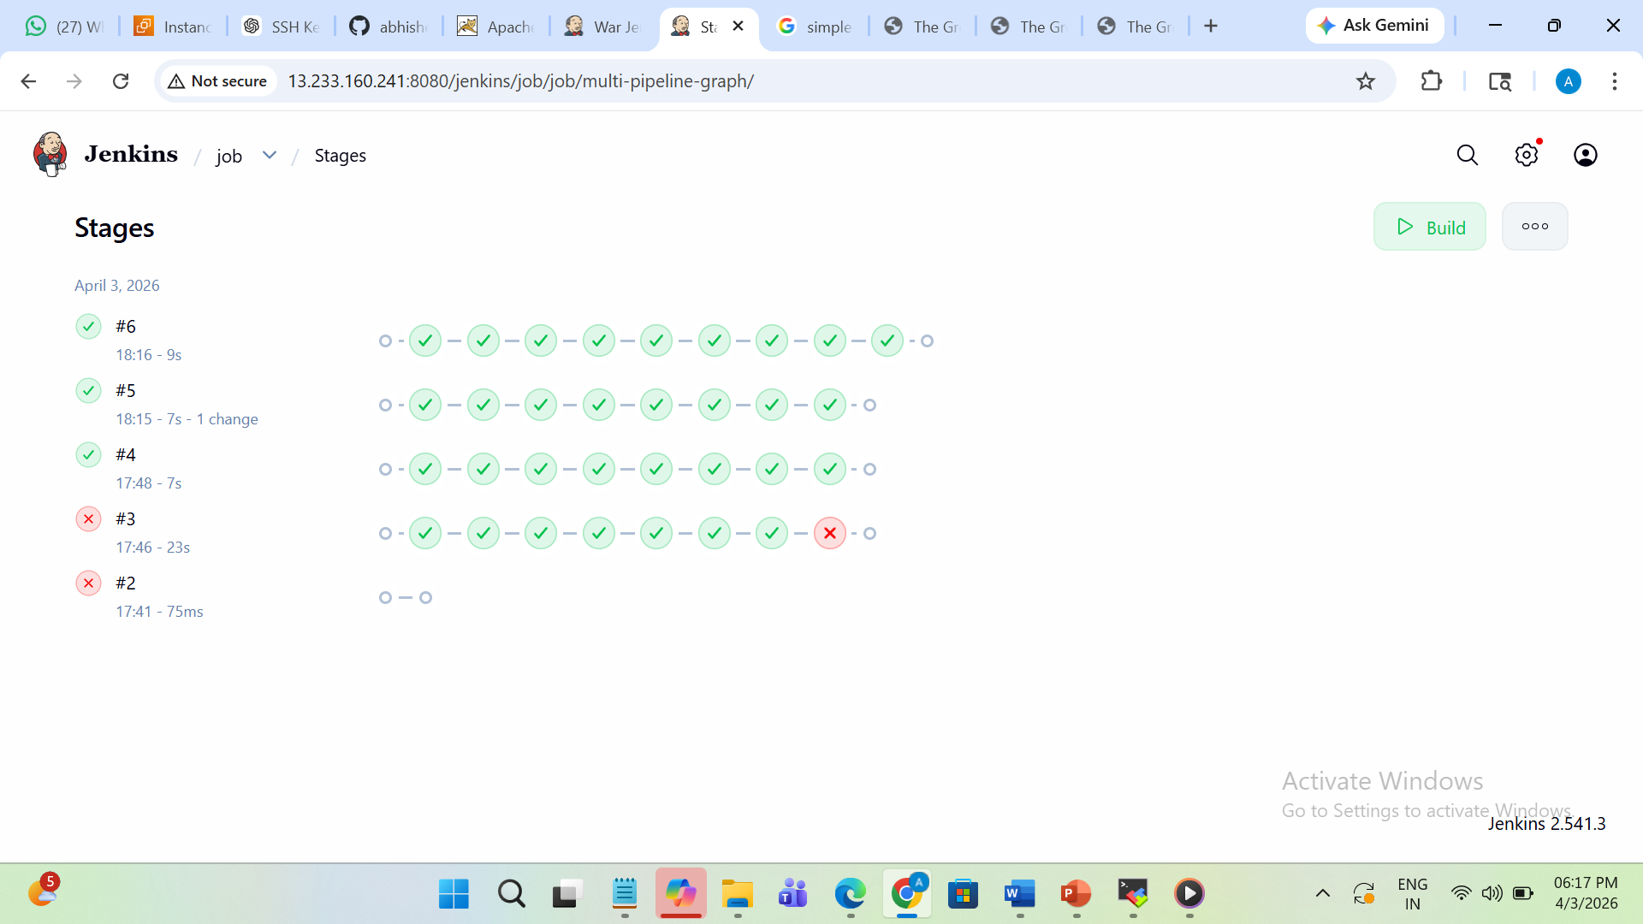

- Here you can see Docker container and volume are created.
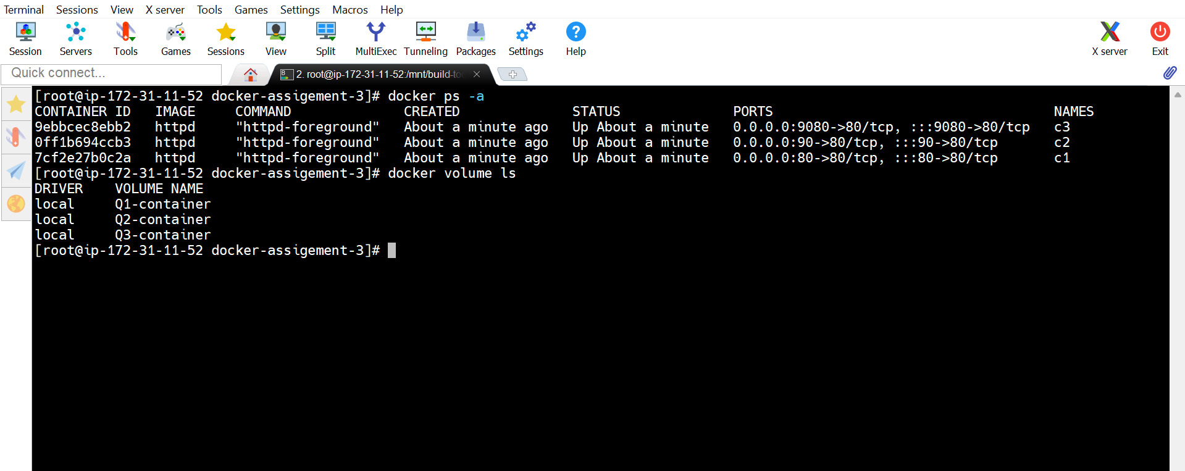

- Her I am doing configuration to execute my job as SCM-git and github repo
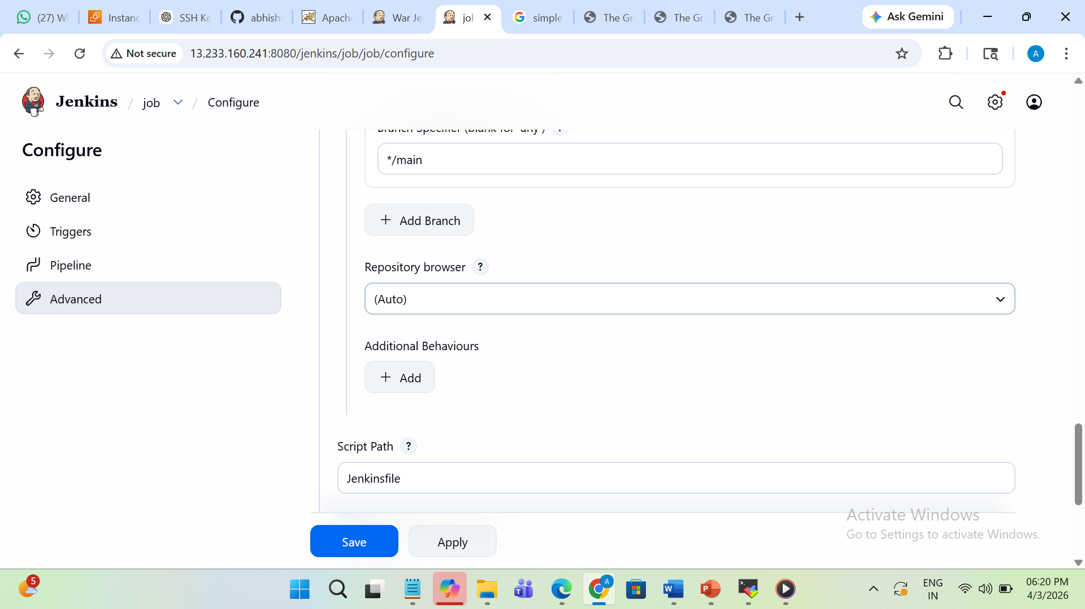
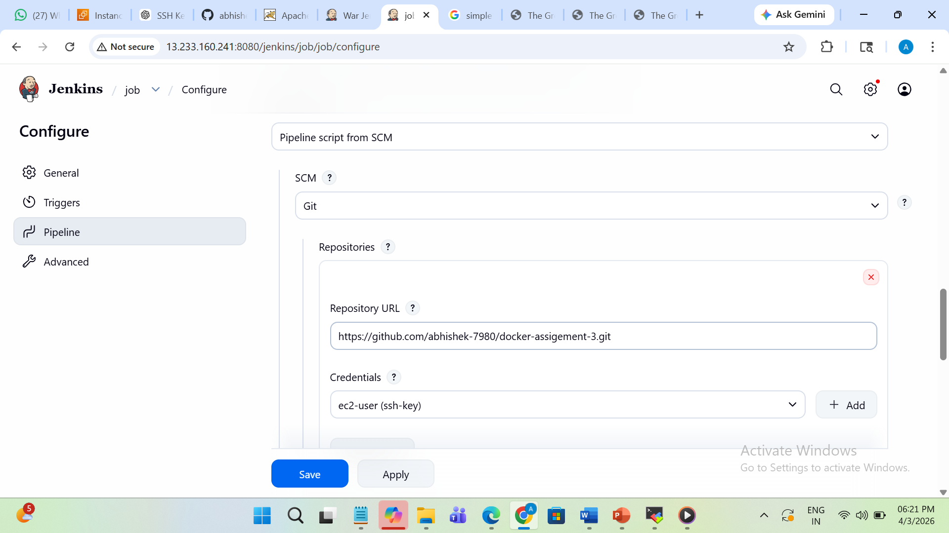

- Here Git Branch in linux terminal along with Jenkins file
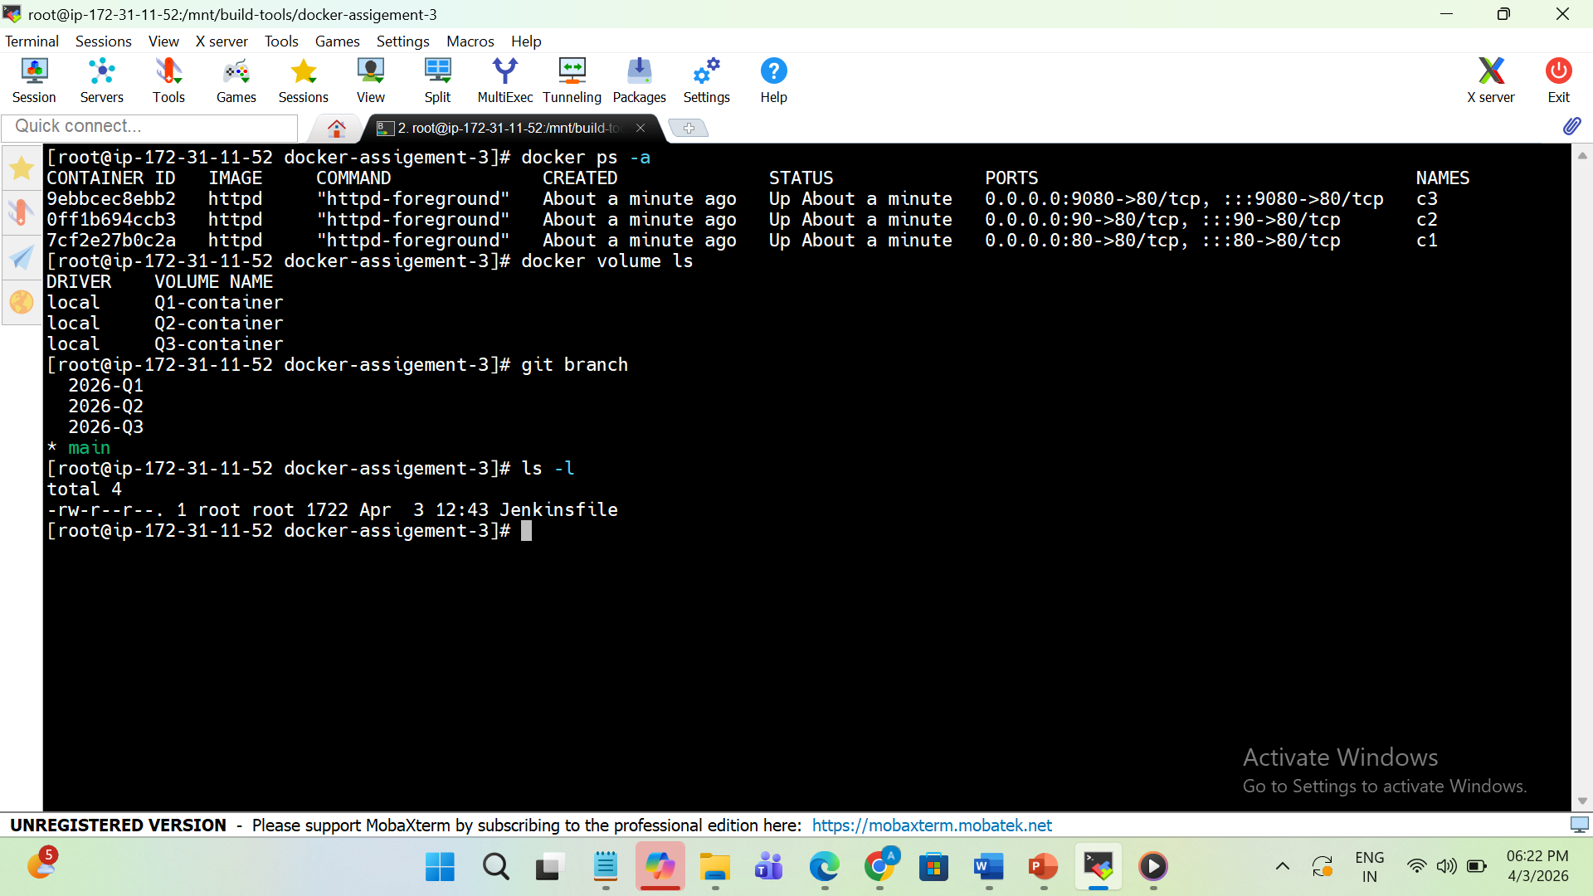

- This is and 2026-Q1 output of index.html file at port 80

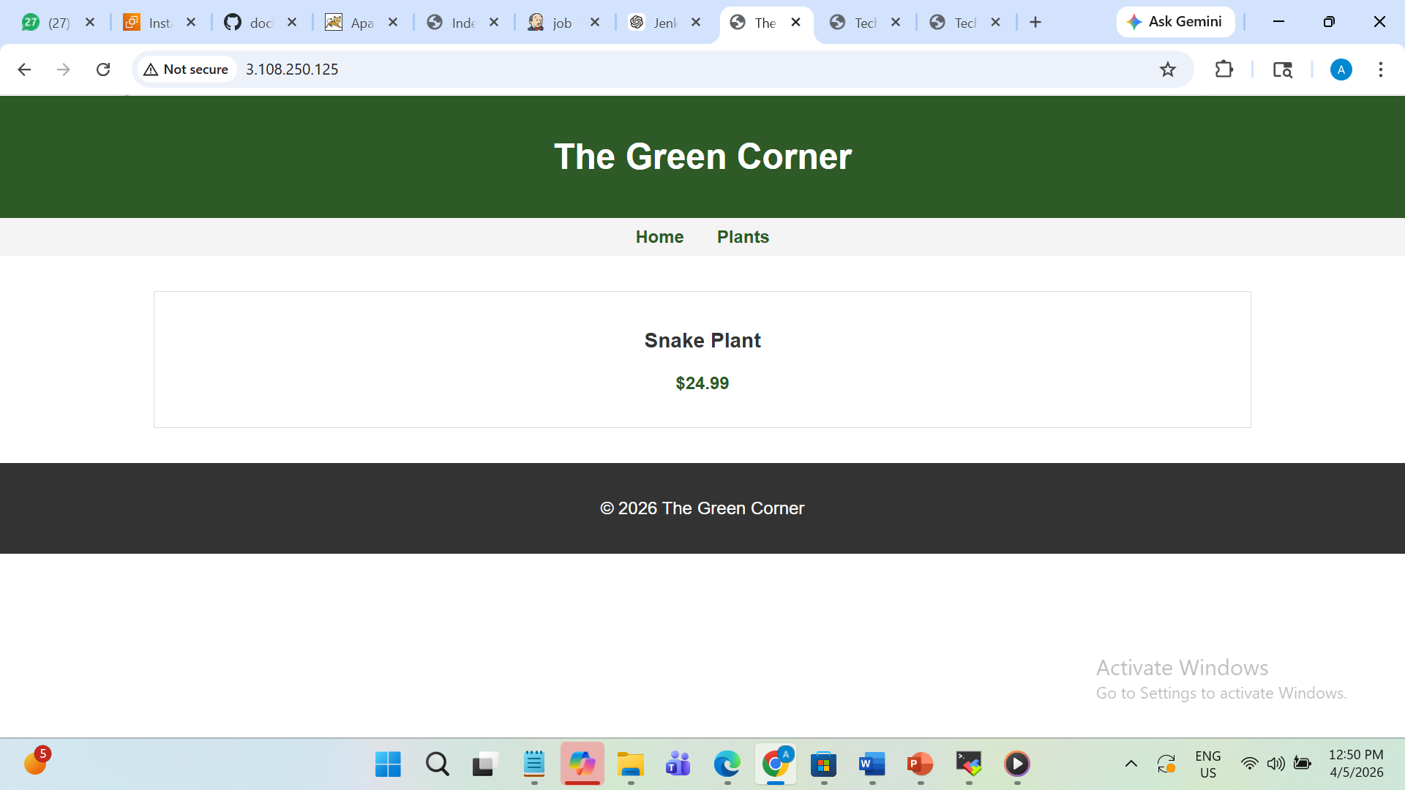
- This is and 2026-Q2 output of index.html file at port 9080

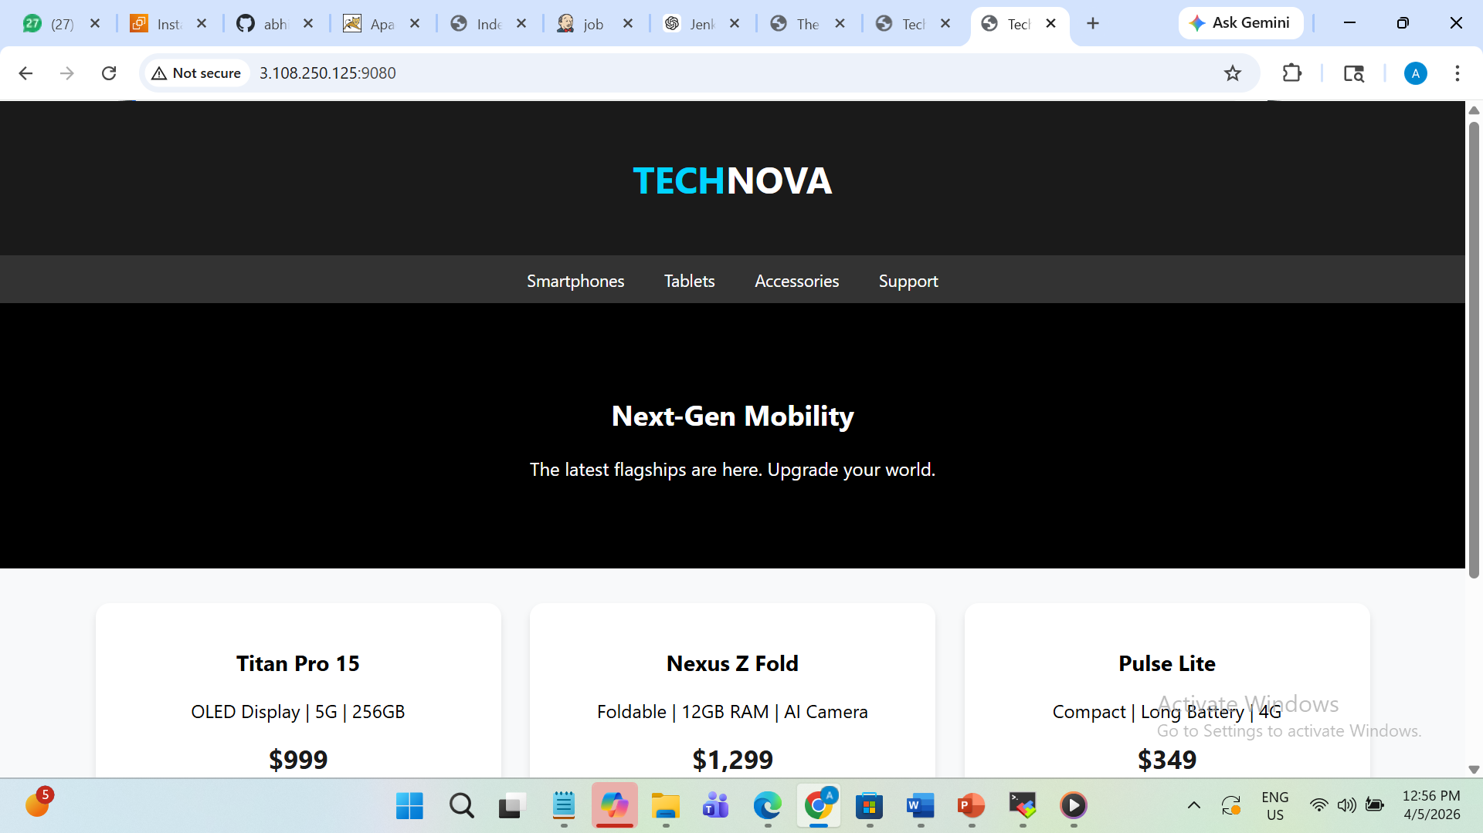

- This is and 2026-Q3 output of index.html file at port 90

